# **WEB STACK IMPLEMENTATION (LAMP STACK) IN AWS**

A technology stack is a set of frameworks and tools used to develop a software product. This set of frameworks and tools are very specifically chosen to work together in creating a well-functioning software. They are acronymns for individual technologies used together for a specific technology product. some examples ara:

* **LAMP** (Linux, Apache, MySQL, PHP or Python, or Perl)
* **LEMP** (Linux, Nginx, MySQL, PHP or Python, or Perl)
* **MERN** (MongoDB, ExpressJS, ReactJS, NodeJS)
* **MEAN** (MongoDB, ExpressJS, AngularJS, NodeJS

**Lamp Stack**

This is a software bundle which is composed of Linux operating system, the Apache HTTP server, the MySQLrelational database management system(RDBMS) and the PHP(Peri, Python) programming language. It was one of the first open source software stacks for the web and remains one of the most common ways to deliver web applications. They serve dynamic web content through CGI scripting and are suitable for building dynamic websites and web applications.

It is stable, simple and powerful.

The Components of Lamp Stack

LAMP stands for Linux, Apache, MySQL, and PHP. Together, they provide a proven set of software for delivering high-performance web applications. Each component contributes essential capabilities to the stack:

* Linux: The operating system. Linux is a free and open source operating system (OS) that has been around since the mid-1990s. Today, it has an extensive worldwide user base that extends across industries. Linux is popular in part because it offers more flexibility and configuration options than some other operating systems.
* Apache: The web server. The Apache web server processes requests and serves up web assets via HTTP so that the application is accessible to anyone in the public domain over a simple web URL. Developed and maintained by an open community, Apache is a mature, feature-rich server that runs a large share of the websites currently on the internet.
* MySQL: The database. MySQL is an open source [relational database management system](https://www.ibm.com/cloud/learn/relational-databases) for storing application data. With My SQL, you can store all your information in a format that is easily queried with the SQL language. SQL is a great choice if you are dealing with a business domain that is well structured, and you want to translate that structure into the backend. MySQL is suitable for running even large and complex sites.
* PHP: The programming language. The PHP open source scripting language works with Apache to help you create dynamic web pages. You cannot use HTML to perform dynamic processes such as pulling data out of a database. To provide this type of functionality, you simply drop PHP code into the parts of a page that you want to be dynamic.

PHP is designed for efficiency. It makes programming easier—and a bit more fun—by allowing you to write new code, hit refresh, and immediately see the resulting changes without the need for compiling. If you prefer, you can swap out PHP in favor of Perl or the increasingly popular Python language.

The objective of this project is to deploy the LAMP stack website in AWS cloud.

**STEP 1 - Setting up the Amazon EC2 Ubuntu server.**

There are several types of Linux distribution such as Redhat, Cent0S, Fedora, Ubuntu etc. For the purpose of this project, I will be using Ubuntu on a AWS EC2 server. The **package manager, apt (advanced package tool)** is also used in installation.

Just like Windows, iOS, and Mac OS, Linux is an operating system. Android is powered by the Linux operating system. An operating system is software that manages all of the hardware resources associated with your desktop or laptop. To put it simply, the operating system manages the communication between your software and your hardware. Without the operating system (OS), the software would not function.

TCP: The Transmission Control Protocol (TCP) is one of the main [protocols](https://en.wikipedia.org/wiki/Communications_protocol) of the [Internet protocol suite](https://en.wikipedia.org/wiki/Internet_protocol_suite). It provides [reliable](https://en.wikipedia.org/wiki/Reliability_(computer_networking)), ordered, and [error-checked](https://en.wikipedia.org/wiki/Error_detection_and_correction) delivery of a stream of [octets](https://en.wikipedia.org/wiki/Octet_(computing)) (bytes) between applications running on hosts communicating via an IP network. Major internet applications such as the [World Wide Web](https://en.wikipedia.org/wiki/World_Wide_Web), [email](https://en.wikipedia.org/wiki/Email), [remote administration](https://en.wikipedia.org/wiki/Remote_administration), and [file transfer](https://en.wikipedia.org/wiki/File_transfer) rely on TCP, which is part of the [Transport Layer](https://en.wikipedia.org/wiki/Transport_layer) of the TCP/IP suite. [SSL/TLS](https://en.wikipedia.org/wiki/Transport_Layer_Security) often runs on top of TCP.

TCP is [connection-oriented](https://en.wikipedia.org/wiki/Connection-oriented_communication), and a connection between client and server is established before data can be sent. The server must be listening (passive open) for connection requests from clients before a connection is established.

Basically, an Ubuntu instance was launched in AWS. In the process, the security, storage, networking etc were defined. The instance was also connected to the terminal through the ‘connect’ tab in AWS and then copying the connecting link as in the image below.

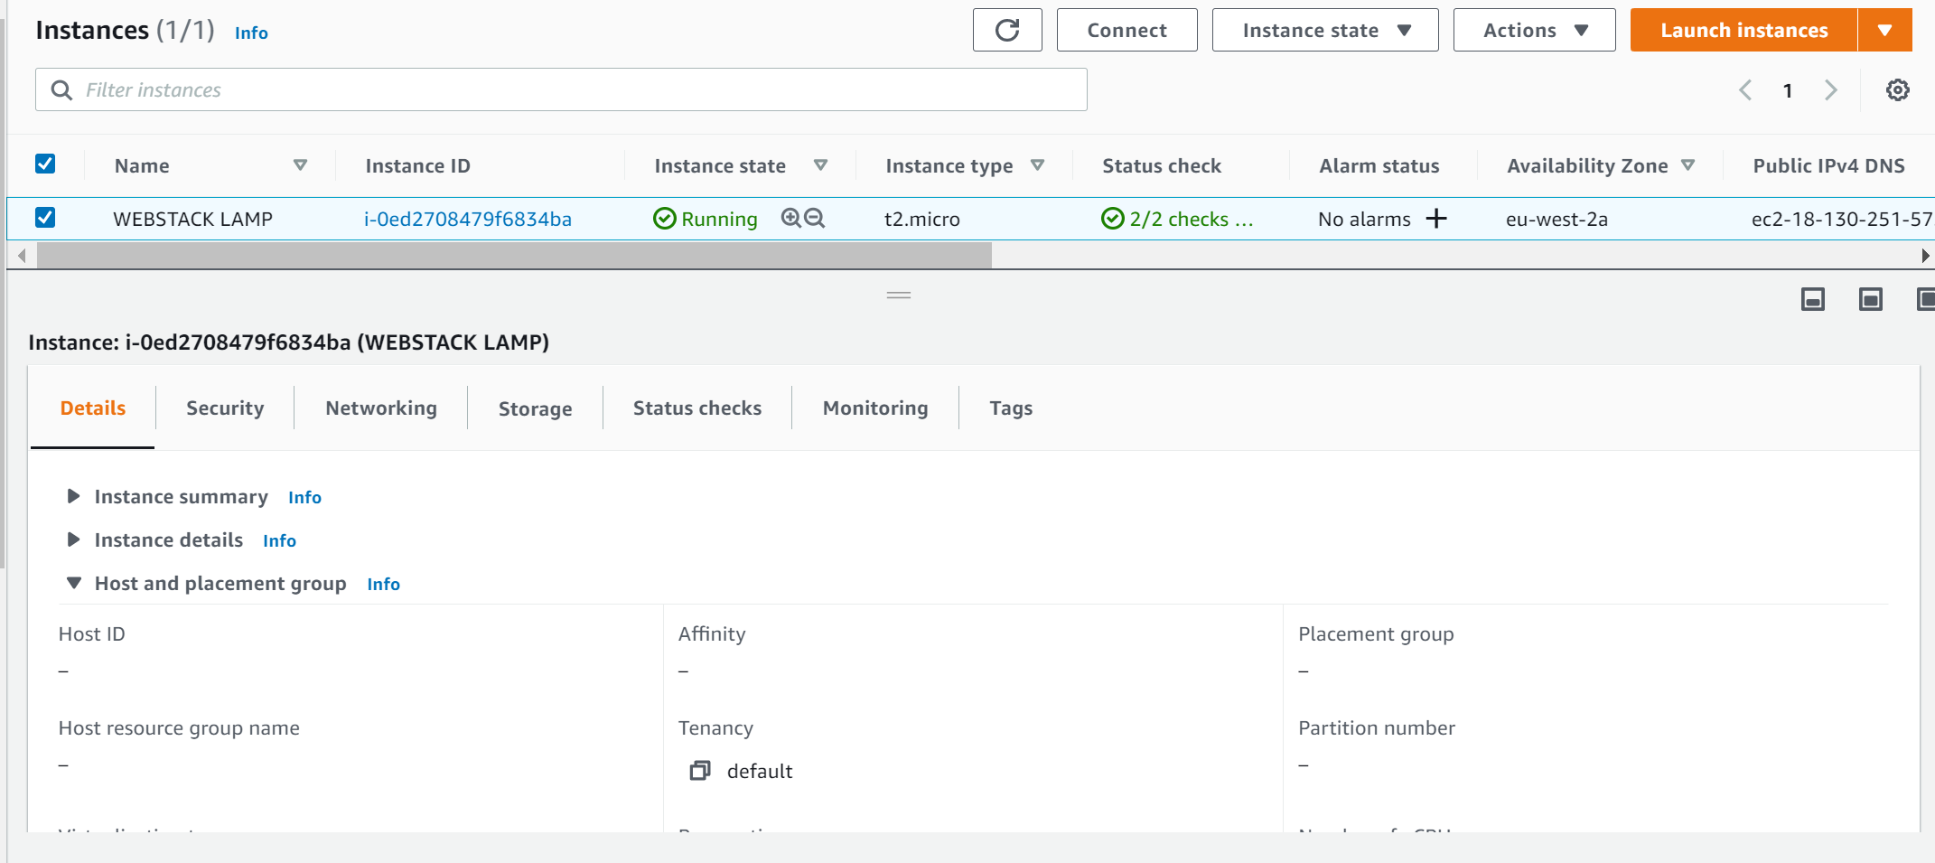

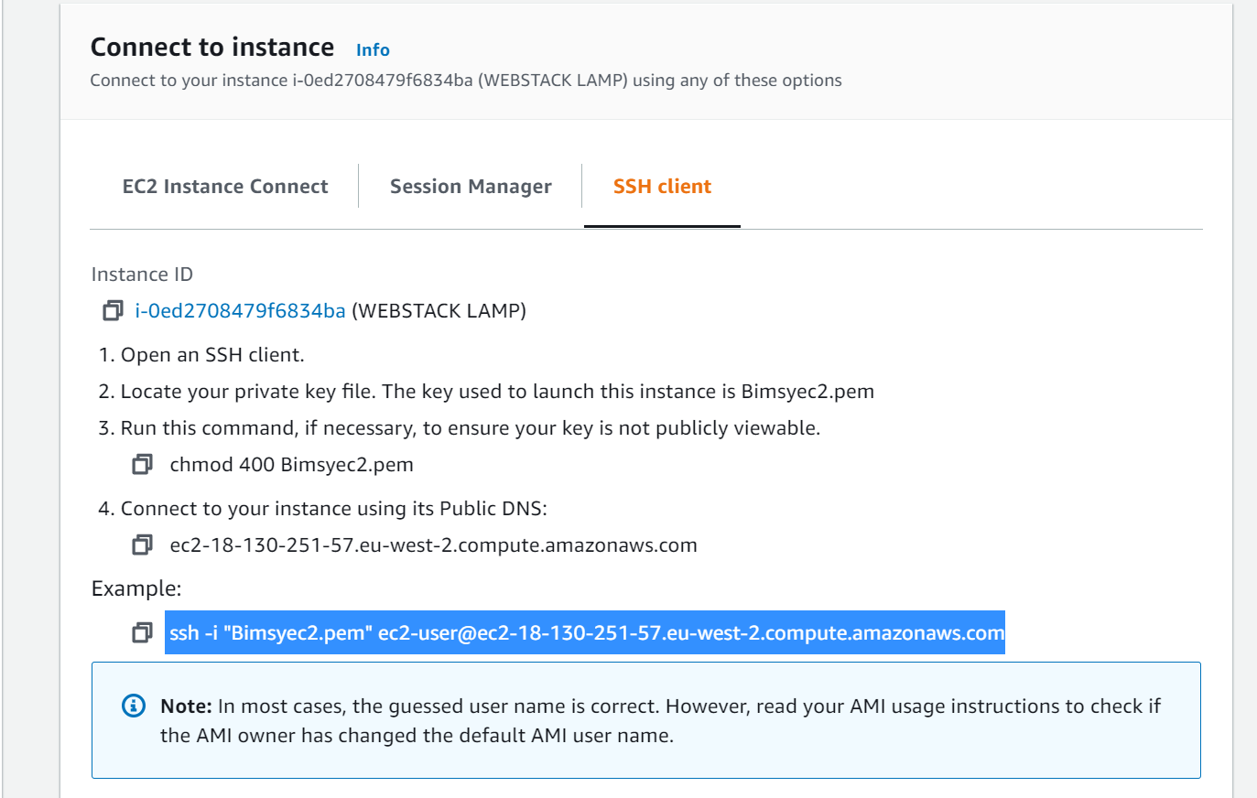

We will now proceed with the LAMP stack implementation with the steps highlighted below:

**STEP 2 — Installing Apache and Updating the Firewall**

[Apache HTTP Server](https://httpd.apache.org/) is the most widely used web server software. Developed and maintained by Apache Software Foundation, Apache is an open source software available for free. It runs on 67% of all webservers in the world. It is fast, reliable, and secure. It can be highly customized to meet the needs of many different environments by using extensions and modules. Most WordPress hosting providers use Apache as their web server software. However, websites and other applications can run on other web server software as well. Such as [Nginx](https://www.nginx.com/), [Microsoft’s IIS](https://www.iis.net/), etc.

The Apache web server is among the most popular web servers in the world. It’s well documented, has an active community of users, and has been in wide use for much of the history of the web, which makes it a great default choice for hosting a website.

Install Apache using Ubuntu’s package manager [‘apt’](https://en.wikipedia.org/wiki/APT_(software)):

#update a list of packages in package manager

$ sudo apt update

#run apache2 package installation

$ sudo apt install apache2

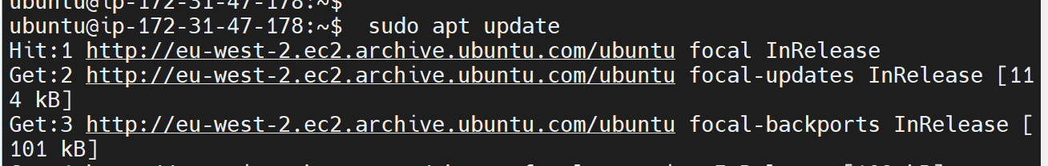

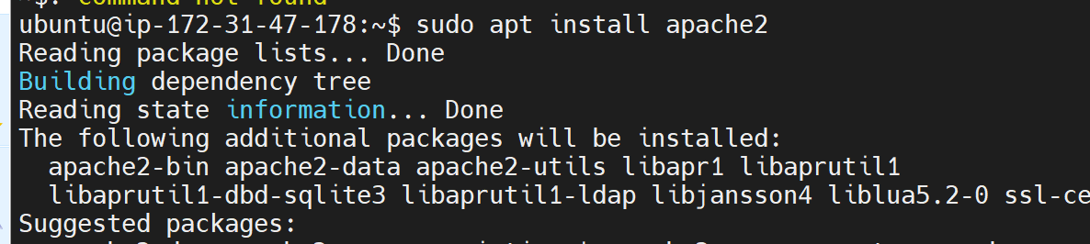

**Verify that apache2 is running as a Service in the OS:**

Use this command: $ sudo systemctl status apache2

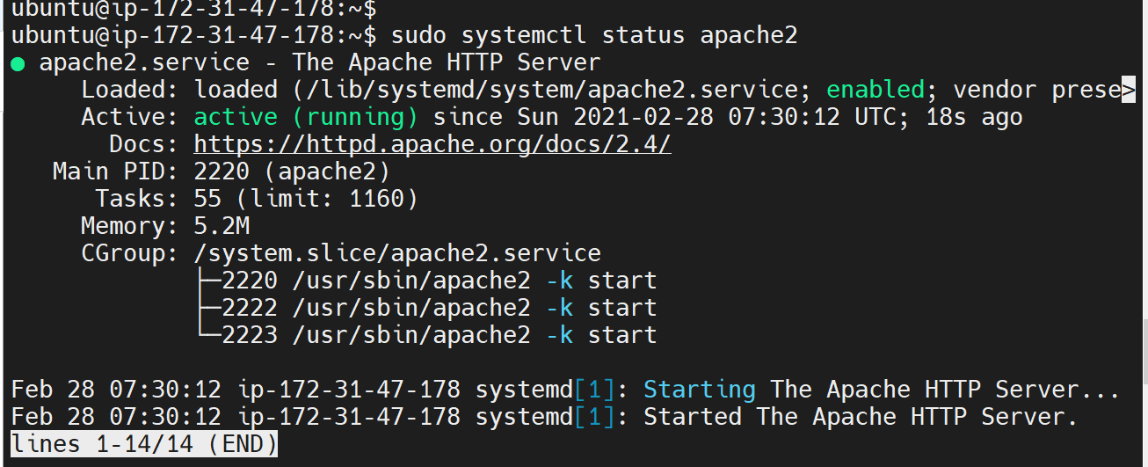

The output above shows that Apache is running ok. This confirms the success of Web Server in the clouds.

**Ensure that the Web server can receive Traffic :**

* Open TCP port 80 which is the default port that web browsers use to access web pages on the Internet. This allows connection through port 80 (http)
* Enable the ufw ([uncomplicated firewall](https://en.wikipedia.org/wiki/Uncomplicated_Firewall))
* And, allow Apache traffic through the firewall.

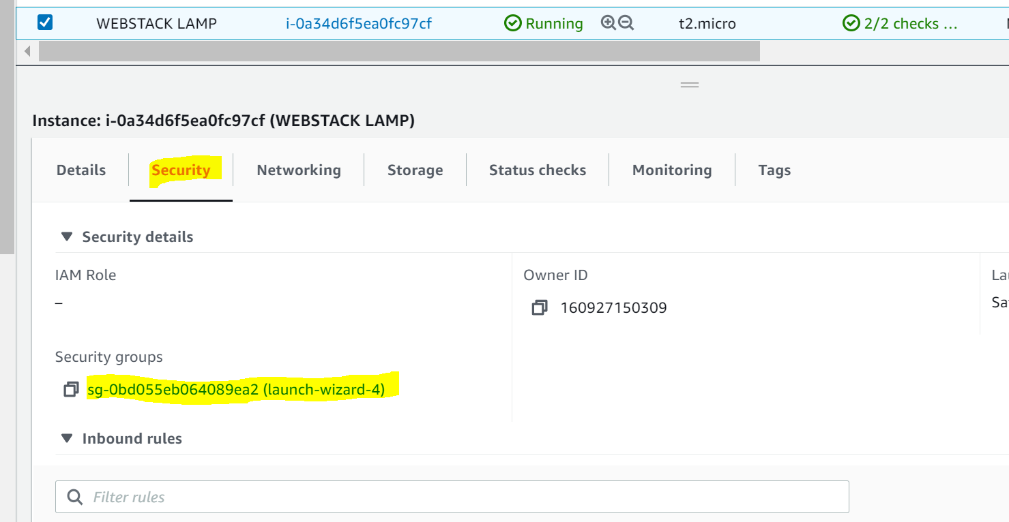

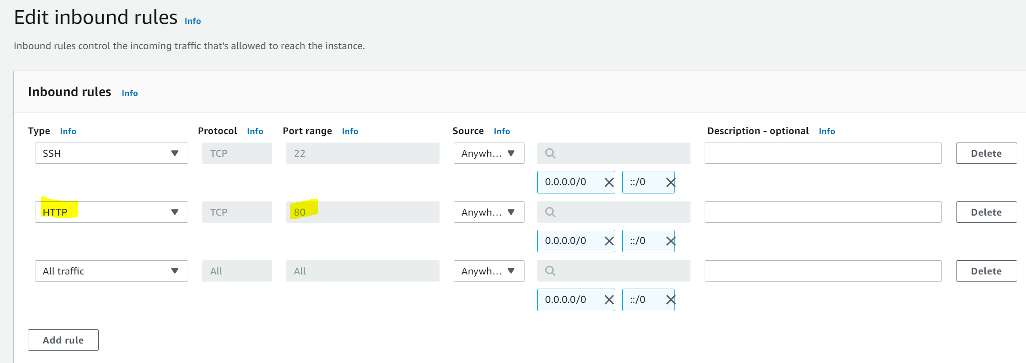

The output above shows that we can access the server locally and from the Internet (Source 0.0.0.0/0 means ‘from any IP address’).

Enable the firewall on the server: $ sudo ufw enable

Allow Apache traffic: $ sudo ufw allow apache

Check all the firewall set up: $ sudo ufw app list

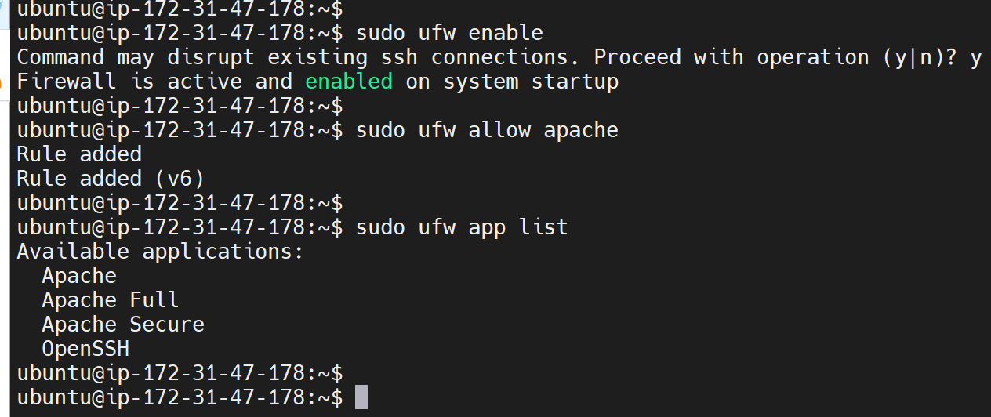

Check if we can access it locally via Ubuntu shell:

$ curl http://localhost:80

or

$ curl <http://127.0.0.1:80>

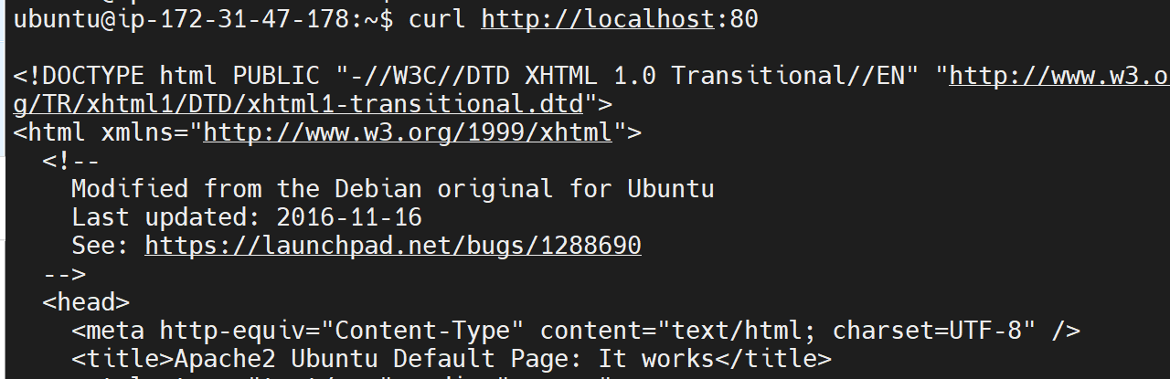

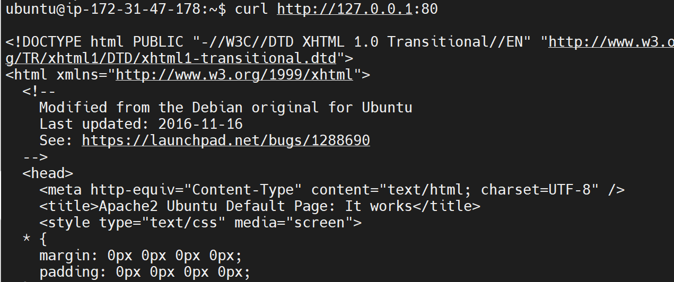

These 2 commands above actually do pretty much the same - they use ‘curl’ command to request our Apache HTTP Server on port 80 (actually you can even try to not specify any port - it will work anyway). The difference is that: in the first case we try to access our server via [DNS name](https://en.wikipedia.org/wiki/Domain_Name_System) and in the second one - by IP address (in this case IP address 127.0.0.1 corresponds to DNS name ‘localhost’ and the process of converting a DNS name to IP address is called “resolution”). We will touch DNS in further lectures and projects.

As an output you can see some strangely formatted test, do not worry, we just made sure that our Apache web service responds to ‘curl’ command with some payload.

**Test Apache HTTP:** In order to see if the server can respond to requests from the Internet. Open a web browser of your choice and try to access following url

http://<Public-IP-Address>:80

<http://3.8.181.56:80>

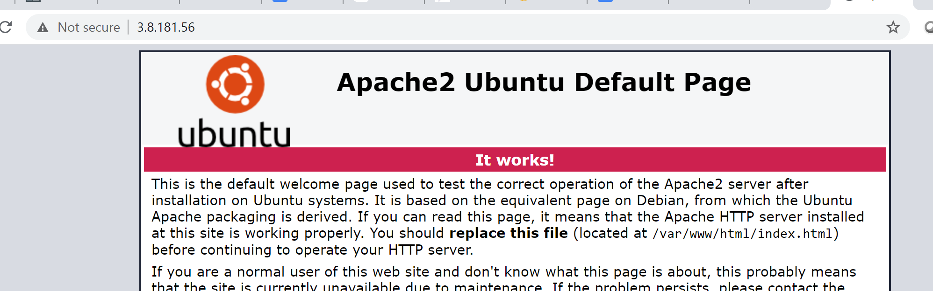

The above output is the apache ubuntu default page and it shows that the web server is now correctly installed and accessible through the firewall.

Another way to retrieve an Public IP address, other than to check it in AWS Web console, is to use following command: curl -s <http://169.254.169.254/latest/meta-data/public-ipv4>

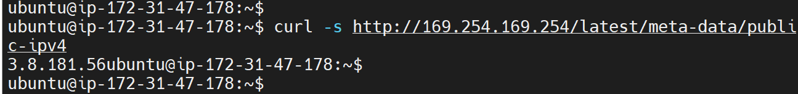

The URL in the browser shall also work if you do not specify port number since all web browsers use port 80 by default.

In fact, it is the same content that you previously got by ‘curl’ command, but represented in nice [HTML](https://en.wikipedia.org/wiki/HTML) formatting by your web browser.

**STEP 3 - Installing MySQL**

As defined above, The database. MySQL is a popular open source [relational database management system](https://www.ibm.com/cloud/learn/relational-databases) used within the PHP environment for storing application data. The Database Management System (DBMS) is used to store and manage data for your site in a relational database.

Acquire and install the Mysql software:

$ sudo apt install mysql-server

When prompted, confirm installation by typing **Y,** and then **ENTER.**

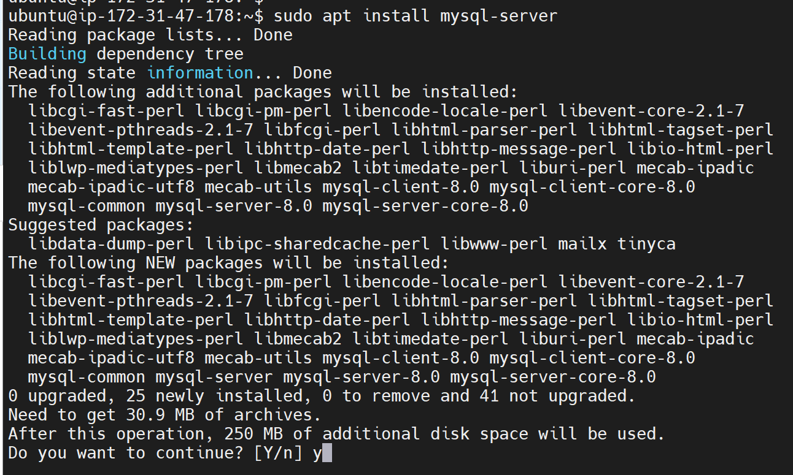

When the installation is finished, it’s recommended to run a security script that comes pre-installed with MySQL. This script will remove some insecure default settings and lock down access to your database system. Start the interactive script by running:

$ sudo mysql_secure_installation.

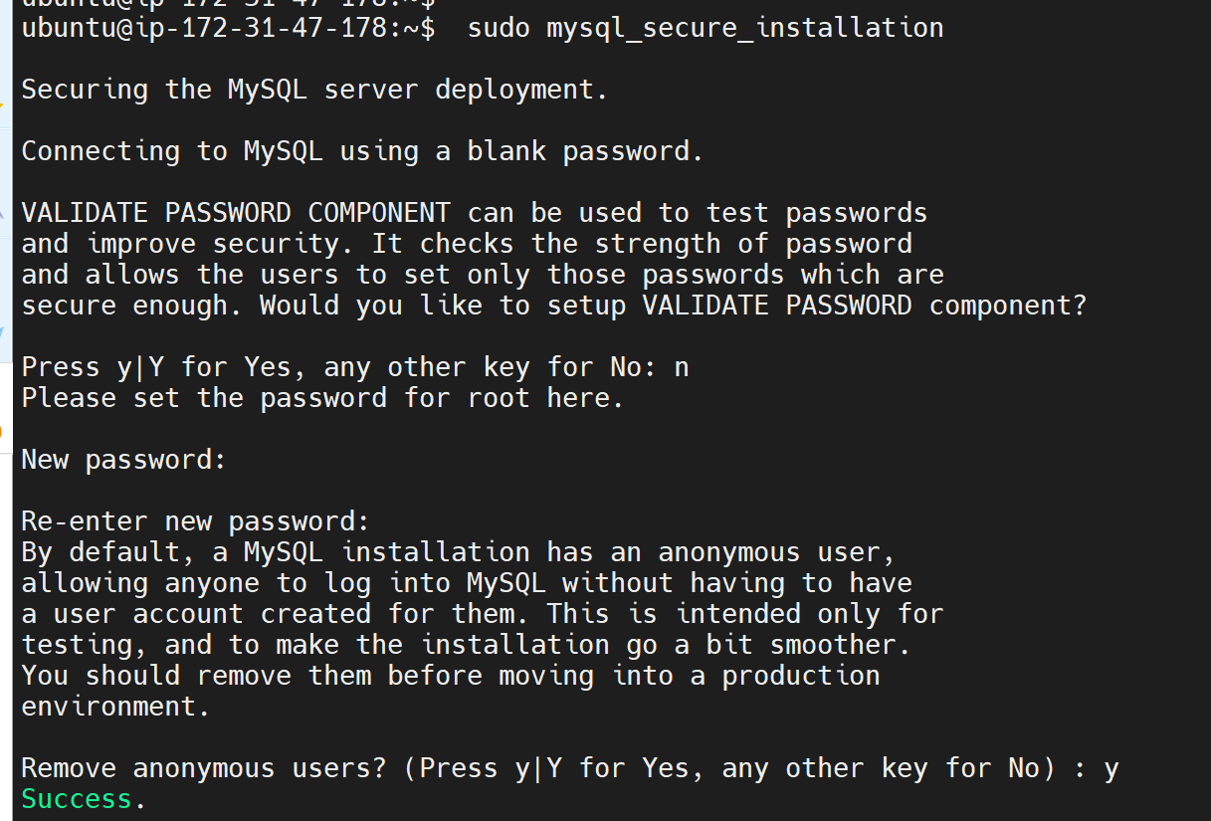

This will ask if you want to configure the **VALIDATE PASSWORD PLUGIN.**

**Note**: Enabling this feature is something of a judgment call. If enabled, passwords which don’t match the specified criteria will be rejected by MySQL with an error. It is safe to leave validation disabled, but you should always use strong, unique passwords for database credentials.

Answer Y for yes, or anything else to continue without enabling.

**If you answer “yes” to the validation question**, you’ll be asked to select a level of password validation. Keep in mind that if you enter 2 for the strongest level, you will receive errors when attempting to set any password which does not contain numbers, upper and lowercase letters, and special characters, or which is based on common dictionary words.

**There are three levels of password validation policy:**

**LOW Length >= 8**

**MEDIUM Length >= 8, numeric, mixed case**, **and** **special characters**

**STRONG Length >= 8, numeric, mixed case, special characters and dictionary file**

**Please enter 0 = LOW, 1 = MEDIUM and** **2 = STRONG: 1**

Regardless of whether you chose to set up the **VALIDATE PASSWORD PLUGIN,** your server will next ask you to select and confirm a password for the MySQL **root** user. This is not to be confused with the **system root**. The **database root** user is an administrative user with full privileges over the database system. Even though the default authentication method for the MySQL root user dispenses the use of a password, **even when one is set**, you should define a strong password here as an additional safety measure. We’ll talk about this in a moment.

If you enabled password validation, you’ll be shown the password strength for the root password you just entered and your server will ask if you want to continue with that password. If you are happy with your current password, enter Y for “yes” at the prompt:

**Estimated strength of the password: 100**

**Do you wish to continue with the password provided?(Press y|Y for Yes, any other key for No) : y**

For the rest of the questions, press Y and hit the **ENTER** key at each prompt. This will remove some anonymous users and the test database, disable remote root logins, and load these new rules so that **MySQL** immediately respects the changes you have made.

**Test MySQL:**

Log in to the MySQL console by typing:

$ sudo mysql

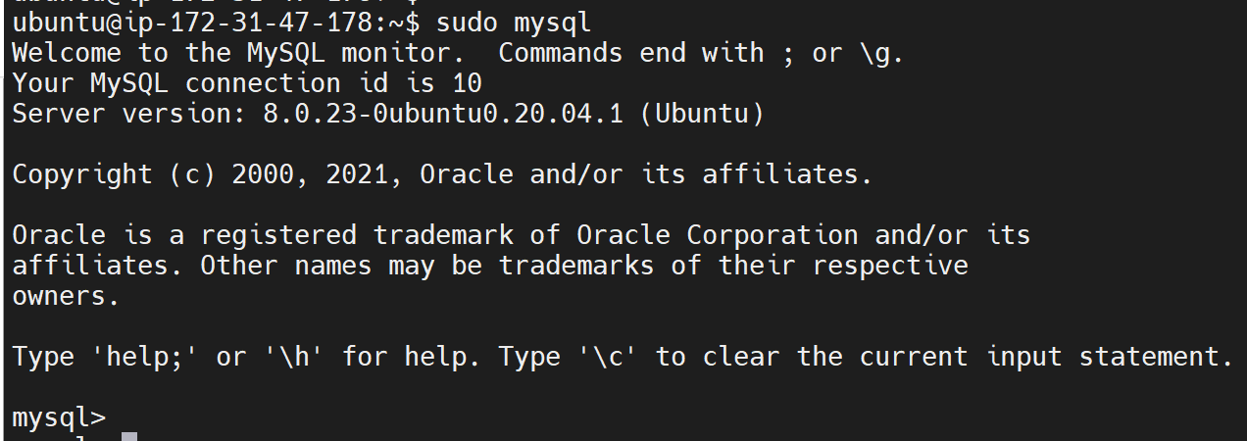

This will connect to the MySQL server as the administrative database user **root**, which is inferred by the use of sudo when running this command. You should see output like this:

To exit the MySQL console, type: mysql> exit

Notice that you didn’t need to provide a password to connect as the **root** user, even though you have defined one when running the **mysql_secure_installation** script. That is because the default authentication method for the administrative MySQL user is **unix_socket** instead of **password.** Even though this might look like a security concern at first, it makes the database server more secure because the only users allowed to log in as the **root** MySQL user are the system users with sudo privileges connecting from the console or through an application running with the same privileges. In practical terms, that means you won’t be able to use the administrative database **root** user to connect from your PHP application. Setting a password for the **root** MySQL account works as a safeguard, in case the default authentication method is changed from **unix_socket** to **password.**

For increased security, it’s best to have dedicated user accounts with less expansive privileges set up for every database, especially if you plan on having multiple databases hosted on your server.

**Note**: the native MySQL PHP library **mysqlnd** doesn’t support **caching_sha2_authentication,** the default authentication method for MySQL 8. For that reason, when creating database users for PHP applications on MySQL 8, you’ll need to make sure they’re configured to use **mysql_native_password** instead.

MySQL server is now installed and secured. Next, is to install PHP, the final component in the LAMP stack.

**STEP 4 - Installing PHP**

Apache has been installed to serve the web content and MySQL installed to store and manage the data. [PHP](https://www.php.net/) is the component of our setup that will process code to display dynamic content to the end user. In addition to the **php** package, you’ll need **php-mysql**, a PHP module that allows PHP to communicate with MySQL-based databases. You’ll also need **libapache2-mod-php** to enable Apache to handle PHP files. Core PHP packages will automatically be installed as dependencies.

To install these 3 packages at once, run:

$ sudo apt install php libapache2-mod-php php-mysql

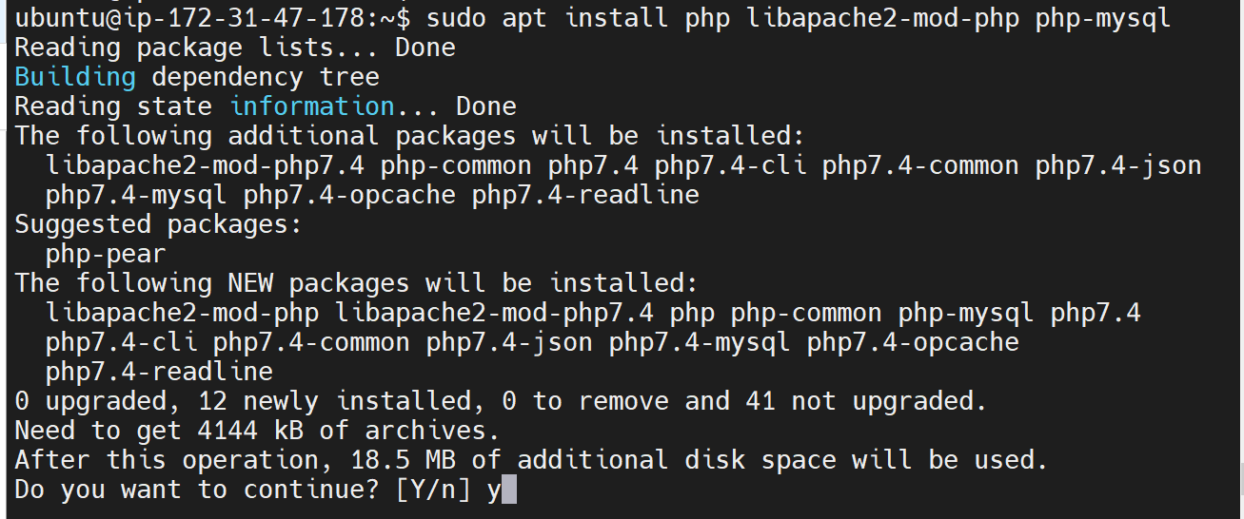

Once the installation is finished, you can run the following command to confirm your PHP version:

**php -v**

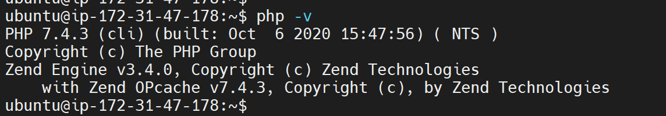

LAMP stack is completely installed and fully operational.

* **L**inux (Ubuntu)
* **A**pache HTTP Server
* **M**ySQL
* **P**HP

To test the LAMP setup with a PHP script, it’s best to set up a proper [Apache Virtual Host](https://httpd.apache.org/docs/2.4/vhosts/) to hold the website's files and folders. Virtual host allows you to have multiple websites located on a single machine and users of the websites will not even notice it.

**STEP 5: Creating and configuring a Virtual Host** for the website using Apache.

## 

## - Set up a domain called **projectlamp**

Apache on Ubuntu 20.04 has one server block enabled by default that is configured to serve documents from the /var/www/html directory. We will leave this configuration as it is and will add our own directory next to the default one.

- View the /var/www/ directory: ls -la /var/www/

- View the /var/www/ directory: ls -la /var/www/html

- Create the directory for projectlamp: $ sudo mkdir /var/www/projectlamp

- Assign ownership of the directory with the $USER environment variable, which will reference the

current system user:

$ sudo chown -R $USER:$USER /var/www/projectlamp

Sample Output

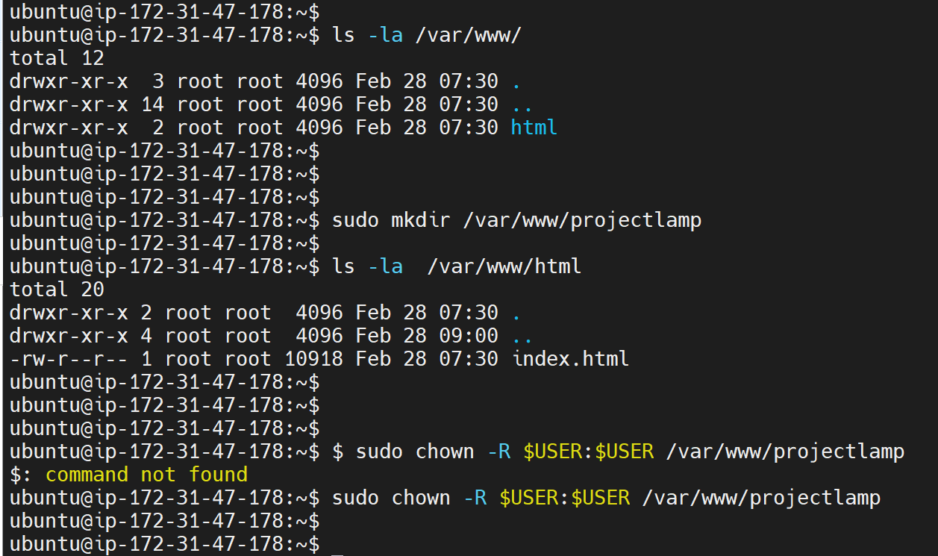

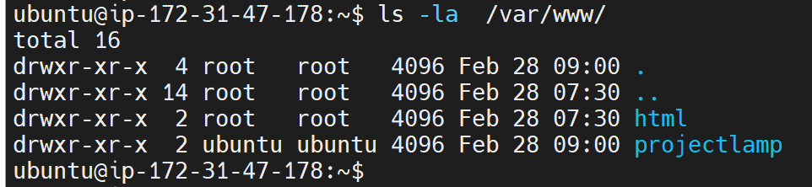

Then, create and open a new configuration file in Apache’s **sites-available** directory using the preferred command-line editor. Here, we’ll be using

$ sudo vi /etc/apache2/sites-available/projectlamp.conf

This will create a new blank file. Paste in the following bare-bones configuration by hitting on i on the keyboard to enter the insert mode, and paste the text:

**<VirtualHost *:80>**

**ServerName projectlamp**

**ServerAlias www.projectlamp**

**ServerAdmin webmaster@localhost**

**DocumentRoot /var/www/projectlamp**

**ErrorLog ${APACHE_LOG_DIR}/error.log**

**CustomLog ${APACHE_LOG_DIR}/access.log combined**

**</VirtualHost>**

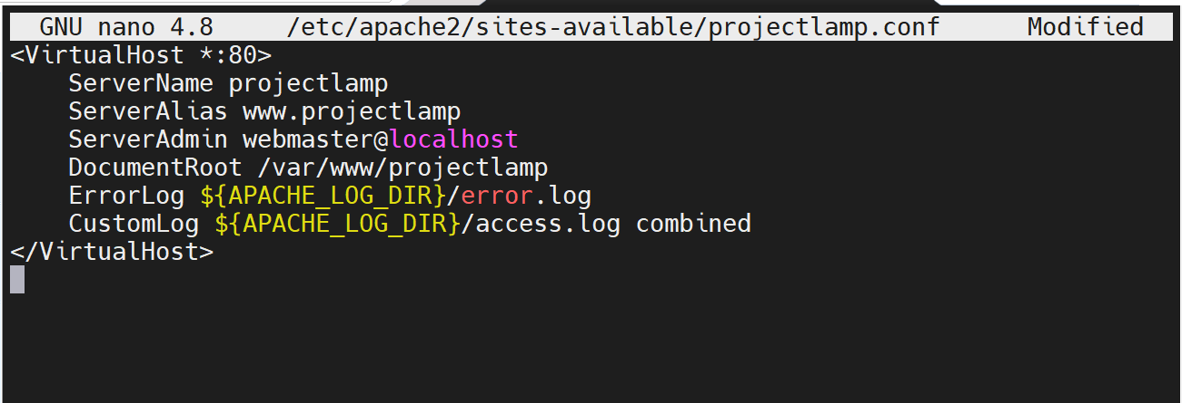

To save and close the file, simply follow the steps below:

1. Hit the **esc** button on the keyboard
2. Type **:**
3. Type **wq.** **w** for **write** and **q** for **quit**
4. Hit **ENTER** to save the file

View the new the new file created

$ sudo ls /etc/apache2/sites-available

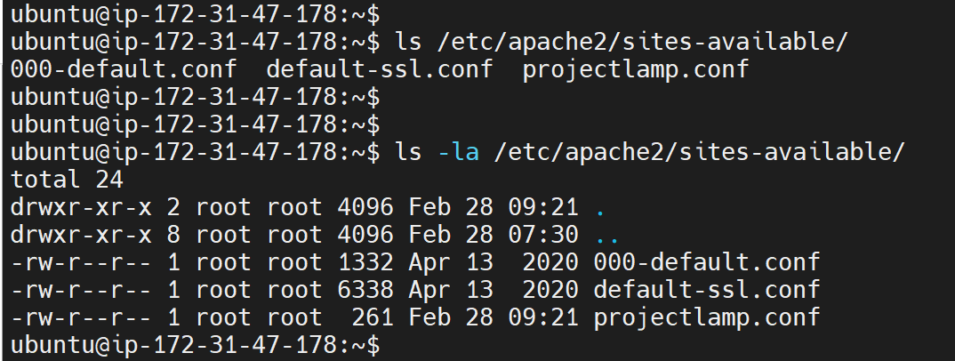

With this VirtualHost configuration, we’re telling Apache to serve **projectlamp** using **/var/www/projectlamp** as its web root directory. If you would like to test Apache without a domain name, you can remove or comment out the options ServerName and ServerAlias by adding a **#** character in the beginning of each option’s lines. Adding the **#** character there will tell the program to skip processing the instructions on those lines.

Now use ***a2ensite*** command to enable the new virtual host:

$ sudo a2ensite projectlamp

You might want to disable the default website that comes installed with Apache. This is required if you’re not using a custom domain name, because in this case Apache’s default configuration would overwrite your virtual host. To disable Apache’s default website use ***a2dissite*** command , type:

$ sudo a2dissite 000-default

To make sure your configuration file doesn’t contain syntax errors, run:

$ sudo apache2ctl configtest

Finally, reload Apache so these changes take effect:

$ sudo systemctl reload apache2

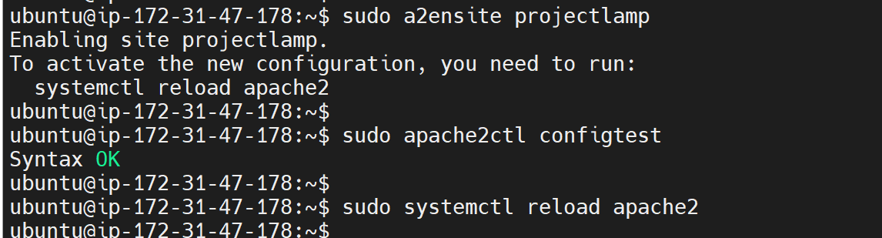

Your new website is now active, but the web root **/var/www/projectlamp** is still empty. Create an index.html file in that location so that we can test that the virtual host works as expected:

**Sudo echo 'Hello LAMP from hostname' $(curl -s http://169.254.169.254/latest/meta-data/public-hostname) 'with public IP' $(curl -s http://169.254.169.254/latest/meta-data/public-ipv4) > /var/www/projectlamp/index.html**

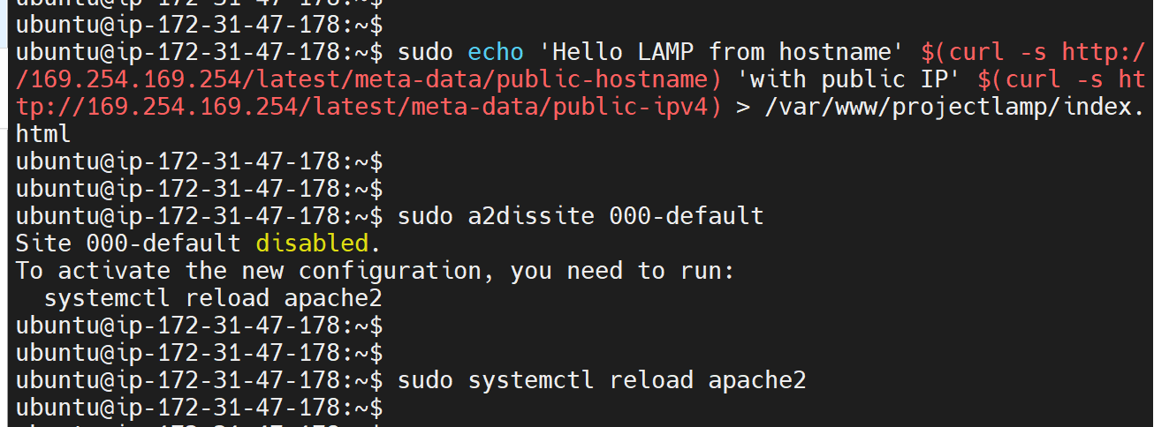

Now go to your browser and try to open your website URL using IP address:

**http://<Public-IP-Address>:80**

[**http://3.8.181.56:80**](http://3.8.181.56:80)

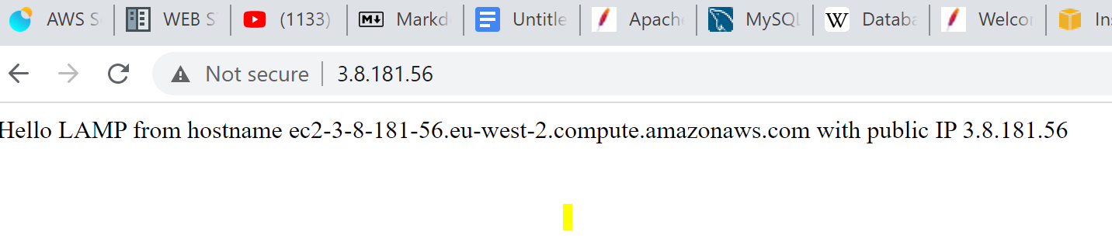

If you see the text from ***‘echo’*** command you wrote to the index.html file, then it means your Apache virtual host is working as expected. In the output you will see your server’s public hostname (DNS name) and public IP address. You can also access your website in your browser by public DNS name, not only by IP - try it out, the result must be the same (port is optional)

**http://<Public-DNS-Name>:80**

**http://ec2-3-8-181-56.eu-west-2.compute.amazonaws.com:80**

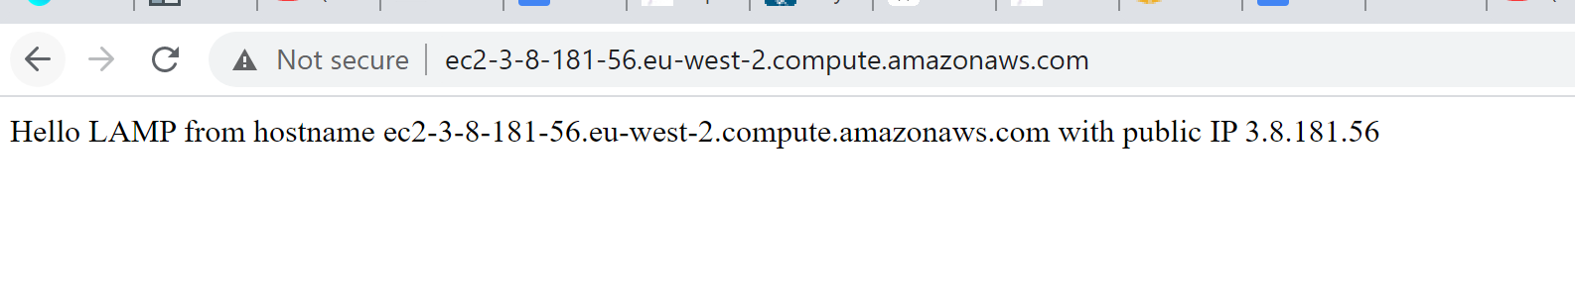

You can leave this file in place as a temporary landing page for your application until you set up an **index.php** file to replace it. Once you do that, remember to remove or rename the **index.html** file from your document root, as it would take precedence over an **index.php** file by default.

**STEP 5: Enable PHP on the website**

With the default Dire**ctoryIndex** settings on Apache, a file named **index.html** will always take precedence over an **index.php** file. This is useful for setting up maintenance pages in PHP applications, by creating a temporary **index.html** file containing an informative message to visitors. Because this page will take precedence over the **index.php** page, it will then become the landing page for the application. Once maintenance is over, the **index.html** is renamed or removed from the document root, bringing back the regular application page.

In case you want to change this behavior, you’ll need to edit the /etc/apache2/mods-enabled/dir.conf file and change the order in which the index.php file is listed within the DirectoryIndex directive:

sudo vim /etc/apache2/mods-enabled/dir.conf

**<IfModule mod_dir.c>**

**#Change this:**

**#DirectoryIndex index.html index.cgi index.pl index.php index.xhtml index.htm**

**#To this:**

**DirectoryIndex index.php index.html index.cgi index.pl index.xhtml index.htm**

**</IfModule>**

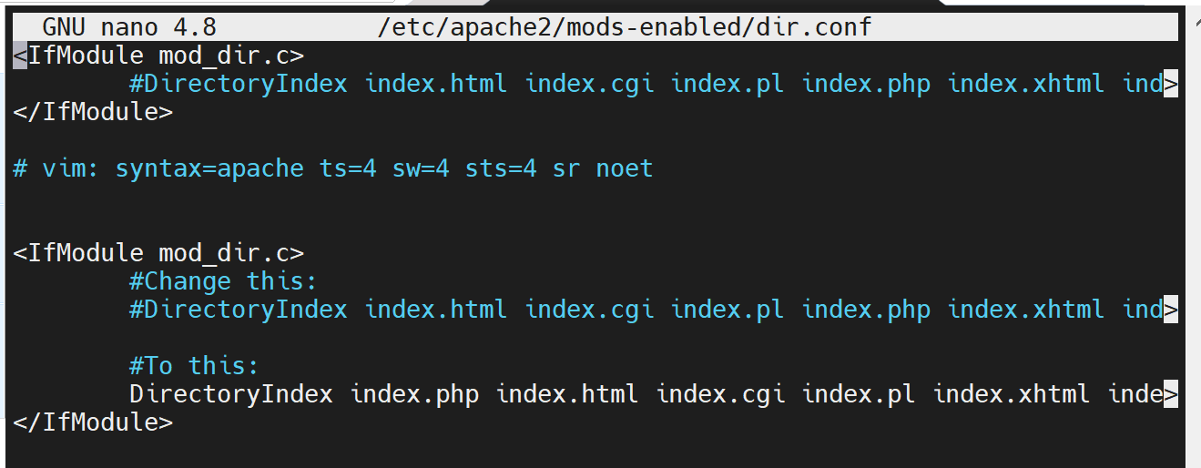

After saving and closing the file, you will need to reload Apache so the changes take effect:

$ sudo systemctl reload apache2

Finally, create a PHP script to test that PHP is correctly installed and configured on the server. THis is will also confirm that Apache is able to handle and process requests for PHP files using the custom location.

- Create a new file named **index.php** inside the custom web root folder(/var/www/projectlamp) :

$ vim /var/www/projectlamp/index.php

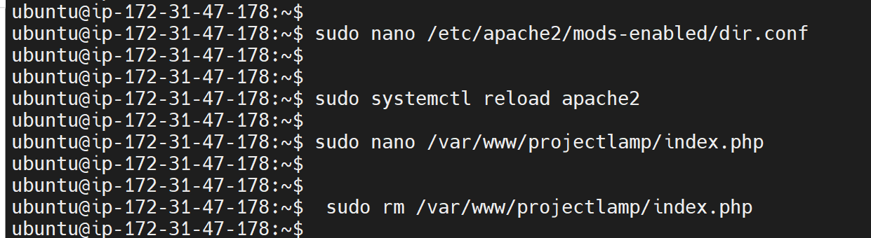

This will open a blank file. Add the following text, which is valid PHP code, inside the file:

**<?php**

**phpinfo();**

Save and close the file.

Refresh the page and the output below should come up.

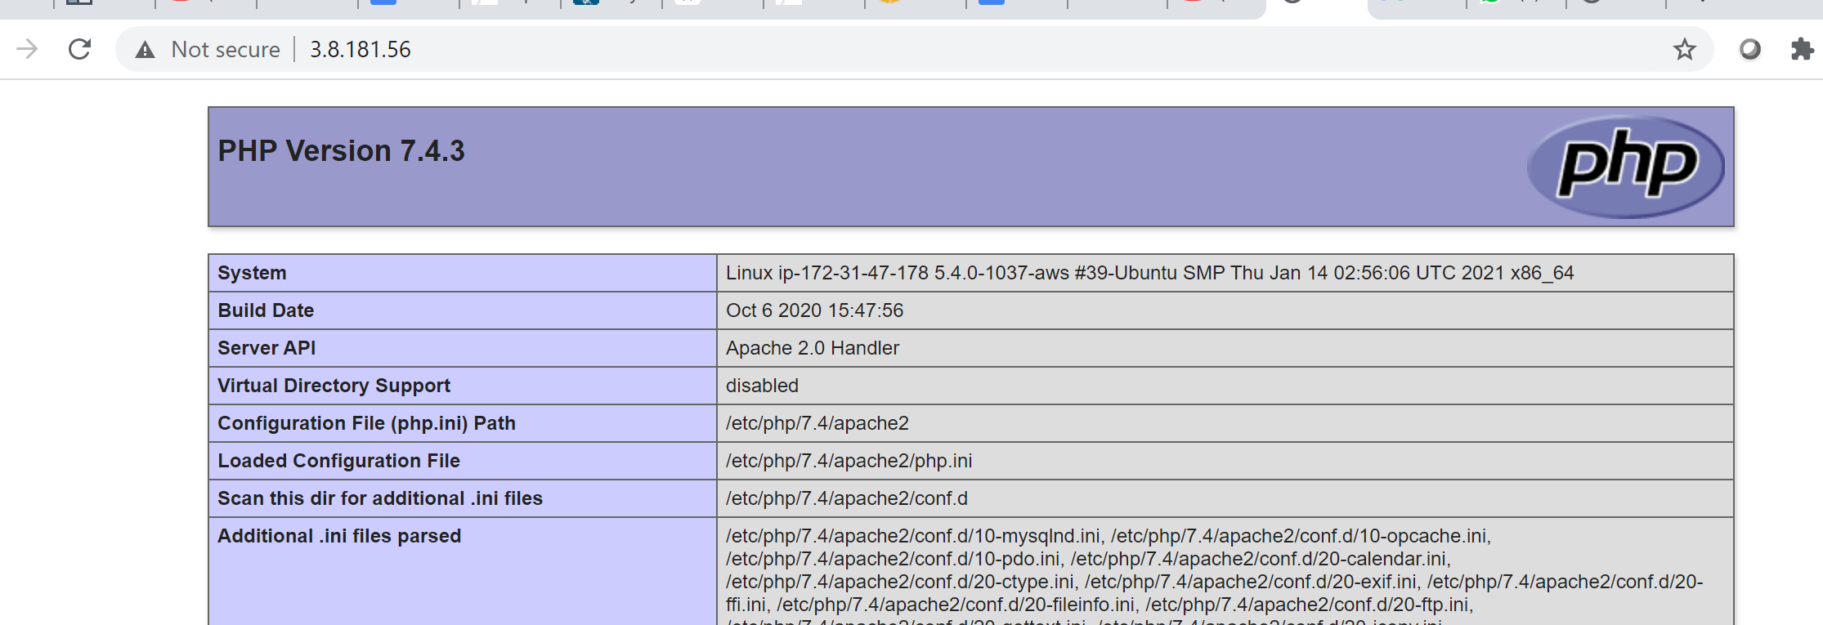

This page provides information about the server from the perspective of PHP. It is useful for debugging and to ensure that the settings are being applied correctly. It also confirms that PHP installation is working as expected.

After checking the relevant information about your PHP server through that page, it’s best to remove the file you created as it contains sensitive information about your PHP environment -and your Ubuntu server. You can use **rm** to do so:

$ sudo rm /var/www/projectlamp/index.php

Credits

Darey.io

Apache: <https://httpd.apache.org/>

DNS: <https://en.wikipedia.org/wiki/Domain_Name_System>

MySQL: <https://www.mysql.com/>

Relational Database: <https://en.wikipedia.org/wiki/Relational_database>

DBMS: <https://en.wikipedia.org/wiki/Database#Database_management_system>

Apache Virtual Host: <https://httpd.apache.org/docs/2.4/vhosts/>